The Axon That Moved
Description | Finding the recording in A Voice Before Launch made me curious about the people who unlocked it. The payphone call associated with it moved to Denver after the original location failed. On the retry day, the player community warned that callers would face a new question. According to the notice published that day, what one-word answer were players supposed to give?
Files | Text-only challenge; publish the player brief after 14 — A Voice Before Launch is solved. No downloadable starter file or container. Submit RCC{word}.
Hint(s) | 1. The recording also named a real-world telephone rendezvous. Investigate the effort to unlock it.  2. The community ledger explains why Rochester failed. The move and retry appear on different days in the community's news.  3. Compare the September 14 and 15, 2004 entries in Netninja's NewsArchives. The retry notice lists the recording and a new question about a captain.
Walkthrough | 1. Carry over standish.wav from A Voice Before Launch. Find standish in the archived NewRecipe3Axons ledger. Its dialogue matches the recording; the comments describe Rochester's unusable and removed telephones.  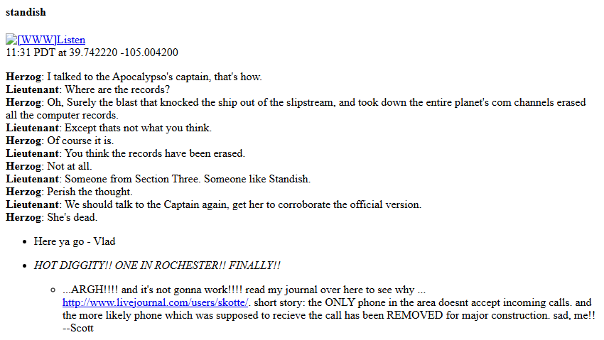  2. Search for the relocated axon in Netninja's NewsArchives. The September 14, 2004 entry announces that standish moved and wishes the Denver beekeepers luck. This is the move announcement, not the retry notice.  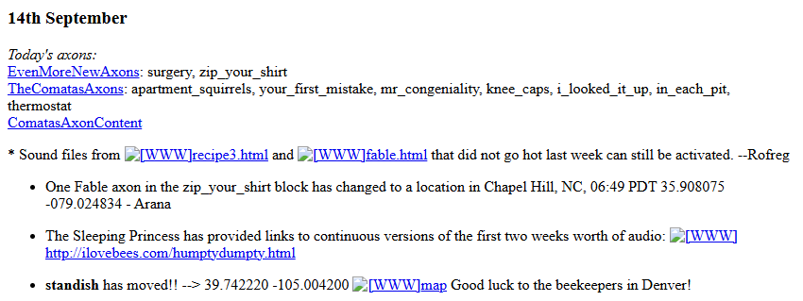  3. Read the September 15 entry immediately above it. Its schedule lists standish, followed by the new phone question: “What is the last name of our captain?” The stated answer is Greene.    4. Submit RCC{greene}. The contemporary guide also distinguishes the changing phone question from each axon's own codeword; standish answers a different check.
Flag | RCC{greene}

